**Functional Requirement:**

* User can start a new game.
* System should display a 3*3 board to user.
* User can input either “X” OR “O”.
* User should be able to choose “X” or “O” to display on the board.
* If user inputs “X”, next input will be “O” automatically and vice versa.
* User can enter their name.
* User can clear the game board.
* User can exit the game anytime.

**Non-functional Requirement:**

* **Learnability**: The system should be easy to learn for user.
* **User friendly**: Interaction between system and user should be easy.
* **Understandability:** User should easily comprehend what system does.

**Use case diagram:**

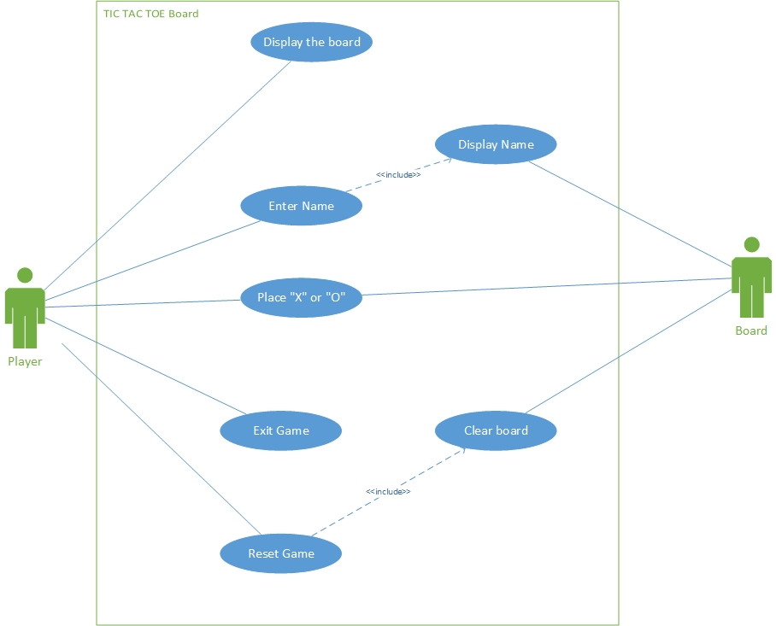

**Use case scenarios:**

|  |  |
| --- | --- |
| Use Case ID | UC1 |
| Use Case Name | Display the board |
| Primary Actor | Player |
| Pre Conditions | Game should be downloaded in the system |
| Success Guarantee (Postconditions) | Game board is displayed to user |
| Main Success Scenario | 1. The user click on start button  2. System displays the game board |

|  |  |
| --- | --- |
| Use Case ID | UC2 |
| Use Case Name | Place “X” or “O” |
| Primary Actor | Player |
| Secondary actor | Game Board |
| Pre Conditions | There should be available space for user to click |
| Success Guarantee (Postconditions) | “X” or “O” is displayed to user |
| Main Success Scenario | 1. The user starts the game  2. The game board is displayed on the screen  3. The user clicks on one of the 9 spaces on the board  4. The user can input either “X” or “O” |
| Extensions (Alternative Scenario) | 3.a. There is no available space on the board, so the board will be reset. |

|  |  |
| --- | --- |
| Use Case ID | UC3 |
| Use Case Name | Reset the game |
| Primary Actor | Player |
| Secondary actor | Game Board |
| Pre Conditions | 1. Game should be downloaded in the system 2. Game board should be displayed to the user |
| Success Guarantee (Postconditions) | Clear game board should be displayed to the player |
| Main Success Scenario | 1. The user clicks reset button. 2. System clears the game board. |